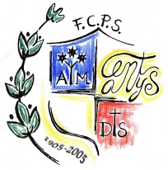

FUNDACIÓ DE CULTURA

I PROMOCIÓ SOCIAL

**COL·LEGI SANT JOSEP**

www.stjosep.com / [fcps@stjosep.com](mailto:fcps@stjosep.com)

**SCIENCE 5TH: TASK 1 (Answer key)**

Hello 5th graders =)

This is the Answer key of the Task 1 you did last week (14th-17th April).

Correct your activities; once they’re done (Answer Key should be used AFTER not before COMPLETING THE ACTIVITIES) and keep them to hand in to your teacher when school is back in session.

If you cannot print the activities (it is NOT necessary) you can write down the answers on a piece of paper or you can use a notebook.

Any questions? Please, don’t hesitate to ask us via email. We will be happy to hear from you:

5th A: [fcps.marta.guasch@stjosep.com](mailto:fcps.marta.guasch@stjosep.com)

5th B & 5th C: [fcps.mariajose.perez@stjosep.com](mailto:fcps.mariajose.perez@stjosep.com)



What’s an ecosystem?

Exercise 2 : Animals: otter

Plants: bushes and grass

Non-living things: water, soil and air

Exercise 4:

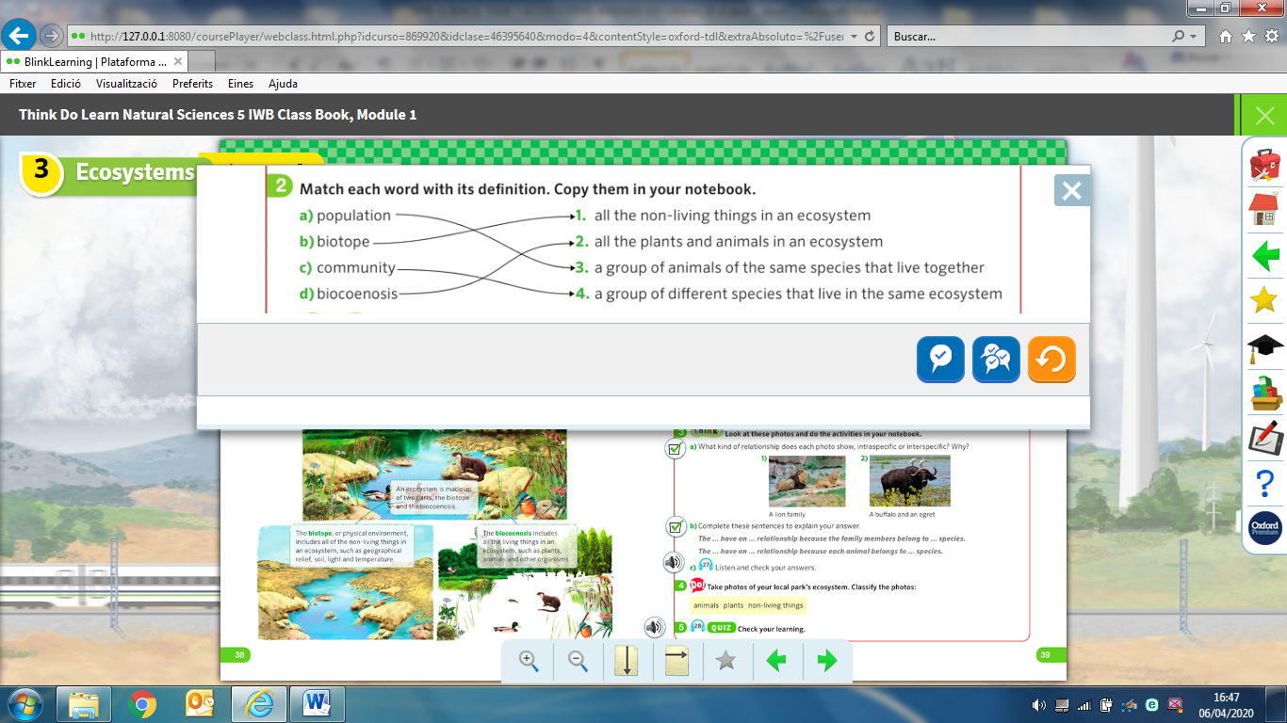

Exercise 5 :

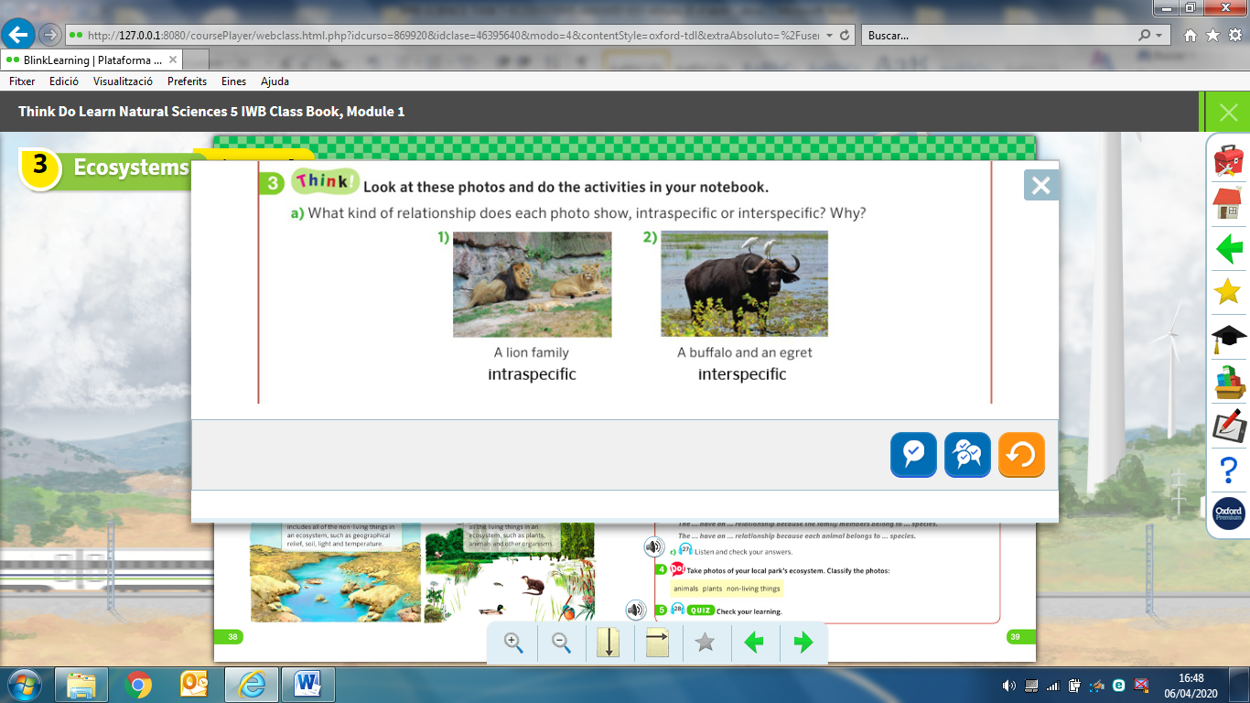

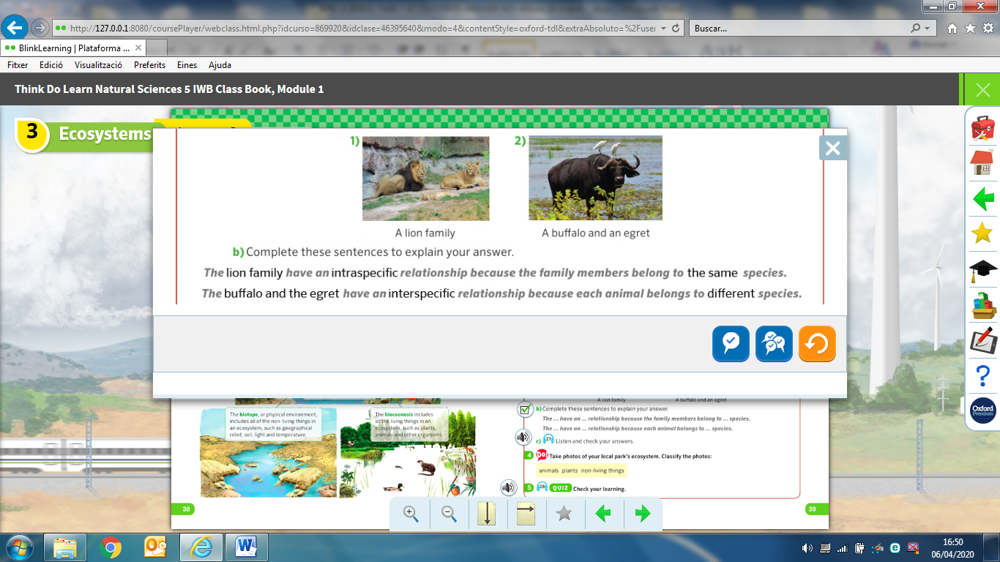

Exercise 6 :

