FUNDACIÓ DE CULTURA
I PROMOCIÓ SOCIAL
COL·LEGI SANT JOSEP
www.stjosep.com / fcps@stjosep.com

ENGLISH 5TH: TASK 1

Hello 5th graders =)!!

I hope that you had fun on your Easter Holidays.
But now is time to work a little bit more.

This week your English teachers want you to start Unit 3! We hope you have fun doing these activities!

Answers will be available for you to correct from Monday, 20th April (next week). But, remember to keep all the tasks, in order to hand them in to your teacher when school is back in session.

If you cannot print the activities (it is NOT necessary) you can write down the answers on a piece of paper or you can use a notebook.

Any questions? Please, don’t hesitate to ask us via email. We will be happy to hear from you:

5th A: fcps.marta.guasch@stjosep.com
5th B & 5th C: fcps.mariajose.perez@stjosep.com

Vocabulary and writing
You can use the dictionary if you need it!
Remember : There is + singular There are + plural
Now write five sentences using there is and there are, describe your bedroom please:
………………………………………………………………………………………………………………………………………………………………………………………………………………………………………………………………………………………………………………………………………………………………………………………………………………………………………………………………………………………………………………………………………………………………………………………………………………………………………………………………………………………………………………………………………………………………………………………

Reading and writing
Exercise 1 :
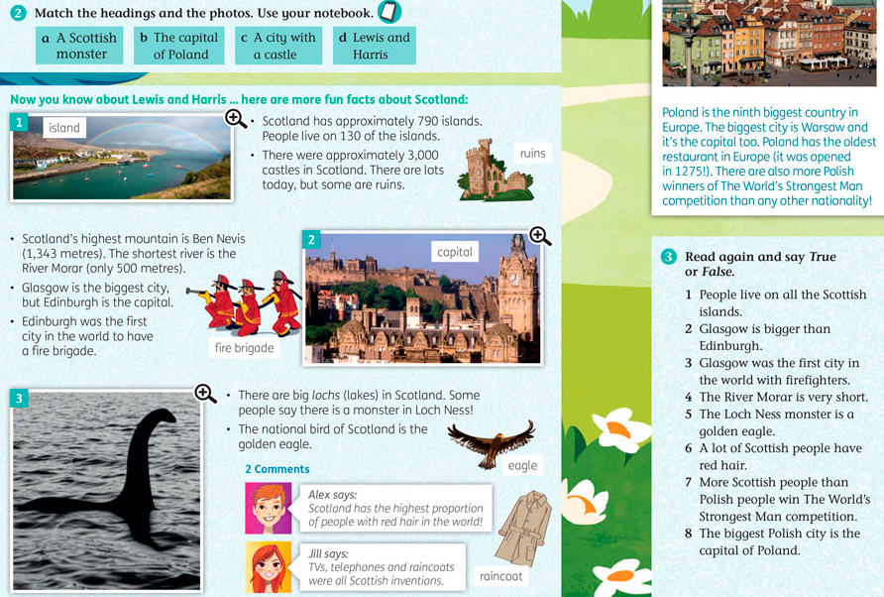
Exercise 2 :
Look at this word : was is the past simple form of is

Exercise 3 :
Exercise 4 :

